**Task 1**

**Step 1**

Generating encryption key



**Step 2**

I created article.txt file then changed the contents to lowercase to get lowercase.txt, followed by removing the punctuation to get plain.txt.

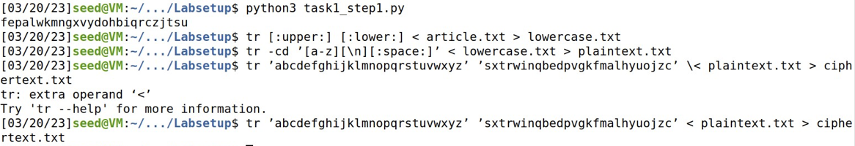



**Step 3**

We used tr command as shown in above screenshot to do encryption.



**Frequency analysis**: 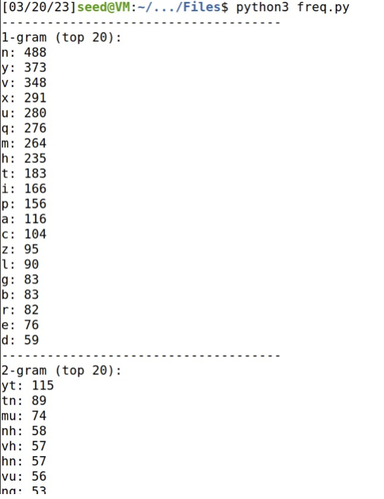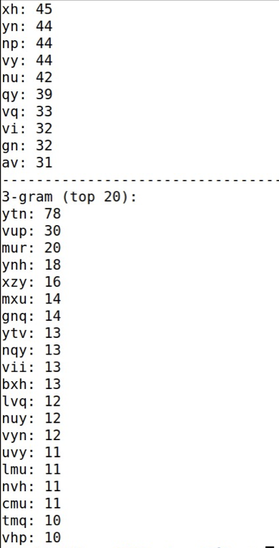

**Decryption:  
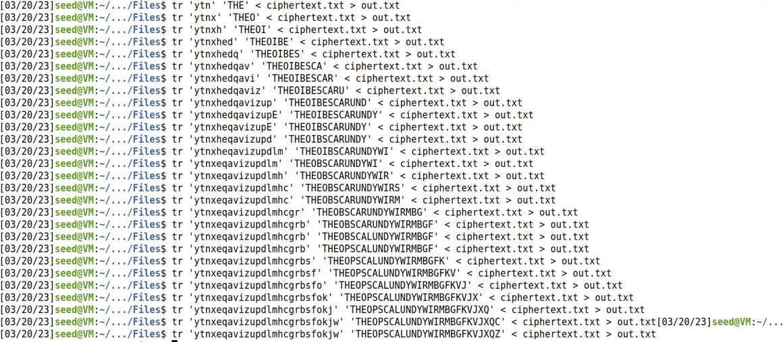**

**Result:  
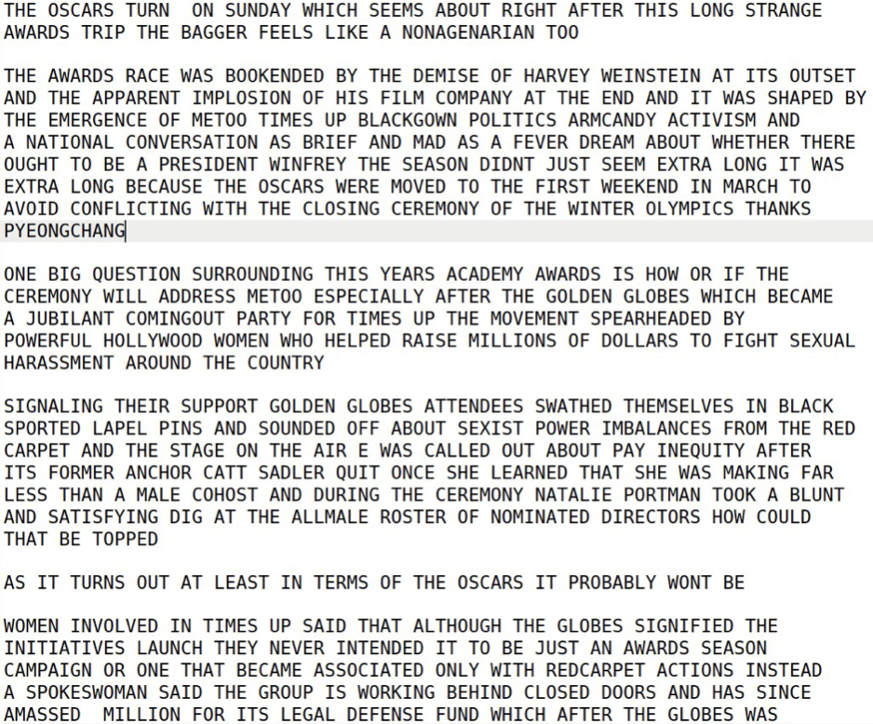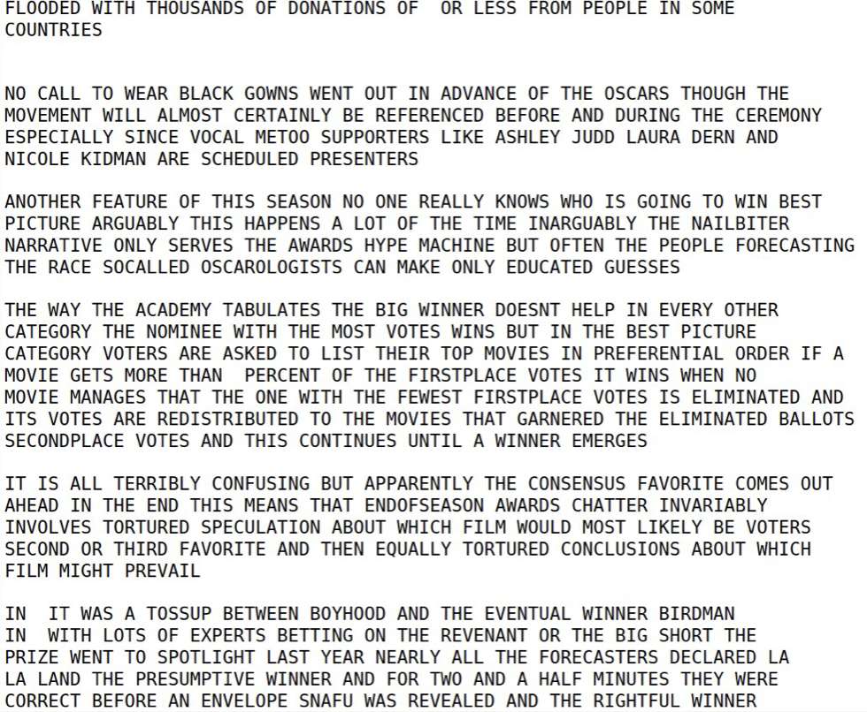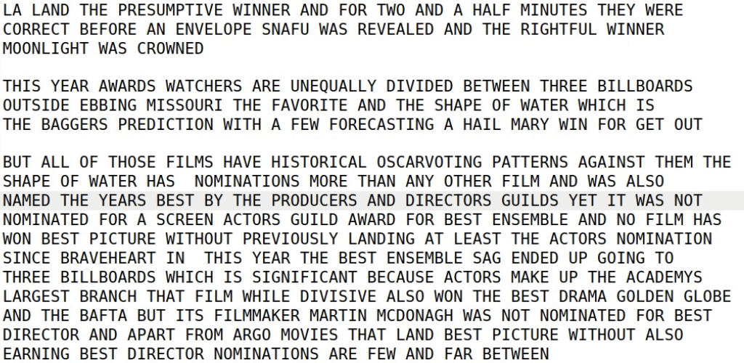**

**Task 2**

**Cipher 1:  
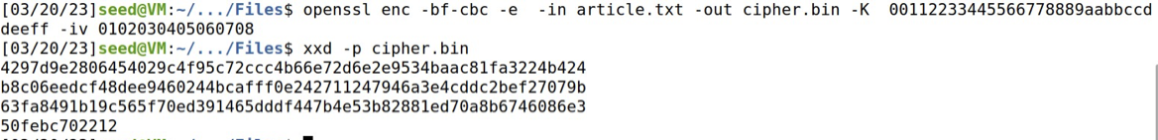Cipher 2:  
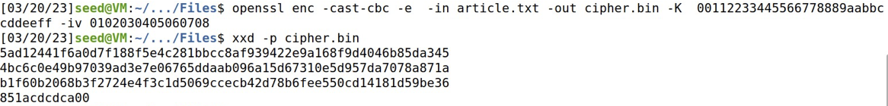Cipher 3:  
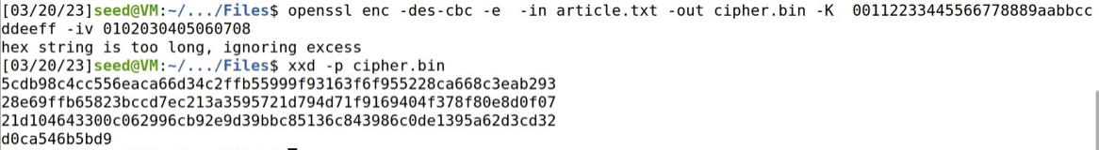**

**Task 6.1**

**Two Different IVs:**

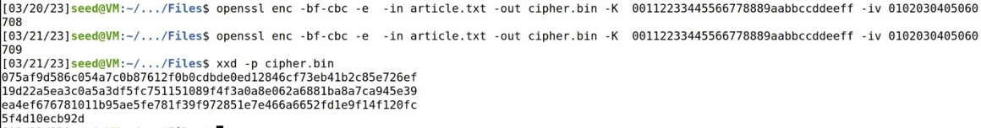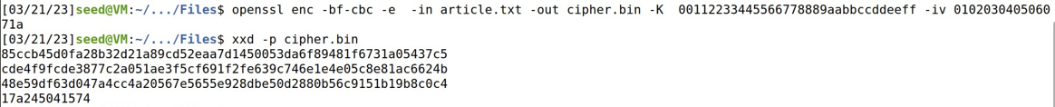

**Same IVs:**

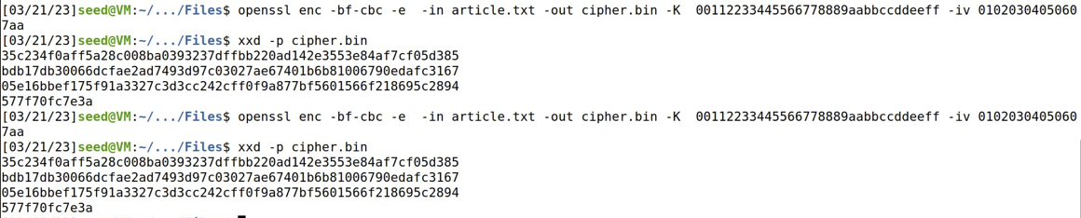

**Observations:**We can see the encryption is same for same IV and different when different IVs is used. So, It is better to have different IVs.

**Task 6.2**

After making some experiment using the same IV, I noticed some results and after I tried using different IV, I came to a better result using the OFB mode. The goal for this activity is to avoid this mistake. The screenshots below are the results I got:

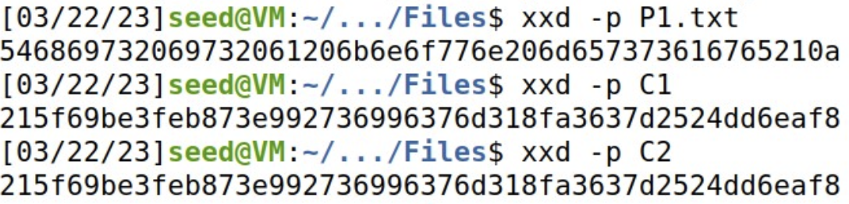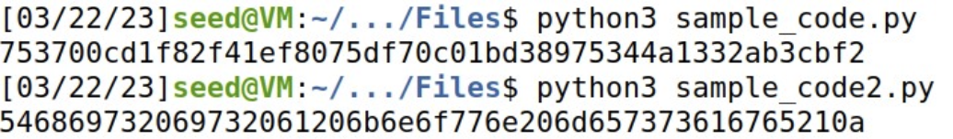

**Task 6.3**

In this task, I tried to see what is going to happen if IVs are predictable and these were the results. My ciphertext and Bob’s generated the same thing

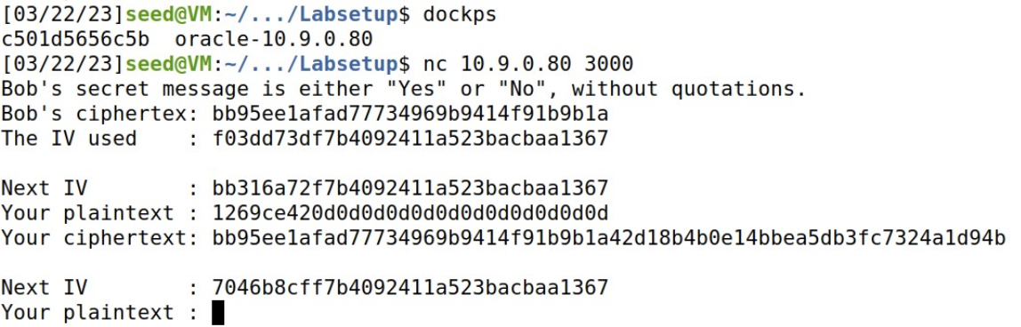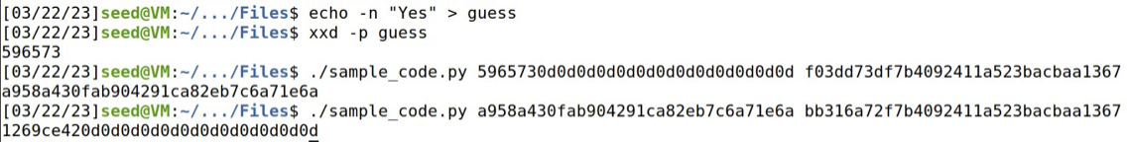

**Task 7**

**Code:**

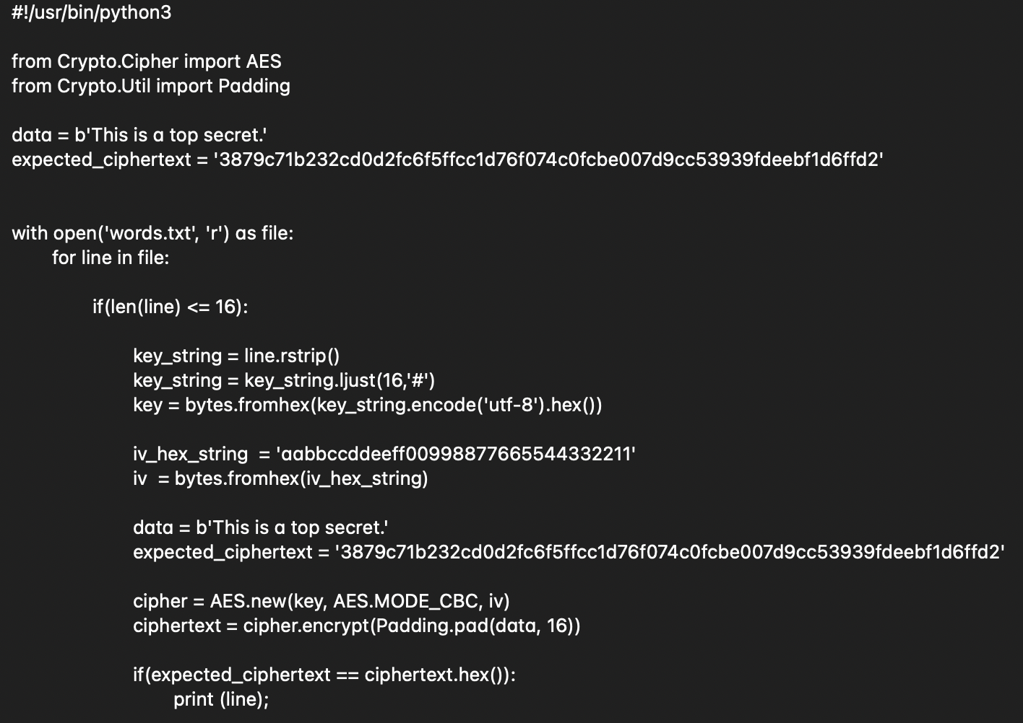

**Result:  
**